**HR Analytic Job Classification**

**Wireframe Documentation**

Author: Pawan Nagar

# Homepage

As per the problem statement, we have divided analysis into three sections: -

1. **Some Tiles for Quick Analysis**:

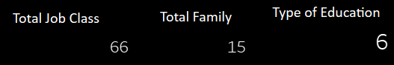

* First tiles are representing total class.
* Second tiles are representing total family.
* Third tiles are representing type of education

1. **column and bar chart visualisation**

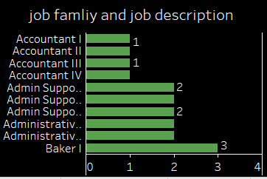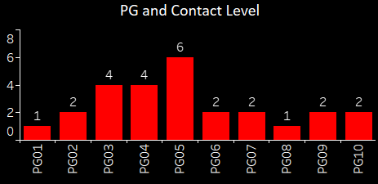

* This chart is representing that PG and contact level
* Bar chart are representing that job family and job description

**3. Chart Visuals**

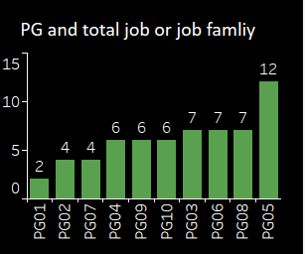

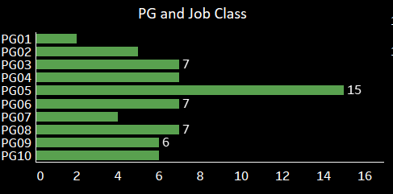

* First is chart are representing that PG and total job family
* Second chart are representing that PG and total jobs.

1. **Education and Grade Based Analysis Visuals**

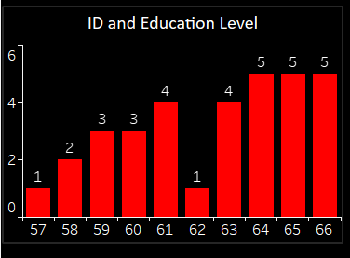

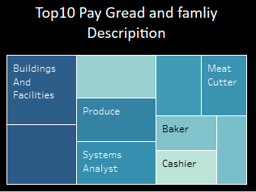

* **First tiles are representing id and education level**
* **Second tile are representing top 10 pay grade and family description**